CMSC 641 Design & Analysis of Algorithms Spring 2023 Section 01 Homework 8

**Faisal Rasheed Khan**

**VB02734**

[**vb02734@umbc.edu**](mailto:vb02734@umbc.edu)

**1 Shipping Coffee**

You work for a company that has extensive coffee operations alongside a river. Each day, coffee beans harvested in plantations upriver must be brought to processing plants downriver. The coffee beans are hand-picked, packed in standard containers and brought to the nearest port on the river. Your company has contracts with individual barge captains to pick up the containers and bring them downriver to the ports near the processing plants.

Unfortunately, each captain has docking privileges only at certain ports. It is your job to coordinate which captain will pick up coffee at which ports and where the coffee will be delivered. Furthermore, you have to contend with the following parameters and constraints:

• Your company has n coffee plantations, each one is near a different upriver port.

• Your company has m processing plants, each one is near a different downriver port.

• Your company has a fleet of k barges.

• The barges are slow and can only make one trip from upriver to downriver each day.

• Each barge can dock at multiple upriver ports and pick up coffee containers from multiple plantations and then float down river and drop off the coffee at multiple processing plants. However, there is not enough time for the barge to travel back upriver to pick up more coffee during the remainder of the day.

• Each plantation produces 10 containers of coffee each day.

• Each processing plant can process 75 containers of coffee each day.

• Each barge can carry 25 containers.

• For each barge captain, you have a list of upriver ports and a list of downriver ports where the captain may dock.

Assignment: Use max flow to produce a solution that maximizes the total number of containers of coffee brought from the plantations to the processing plants without exceeding the capacity of the barges and without delivering more coffee to a processing plant than it can process. Do the following:

1. Using a combination of a diagram, descriptive labels and English sentences, describe how you can transform the problem described above into a flow network.

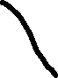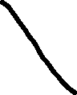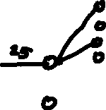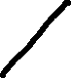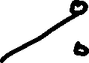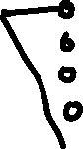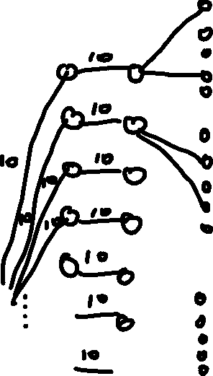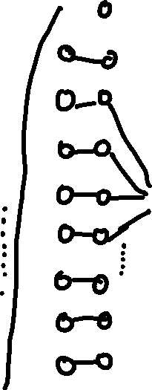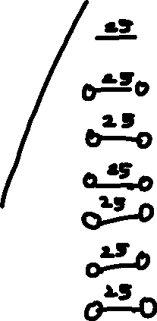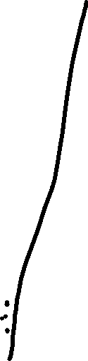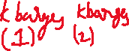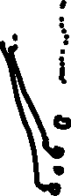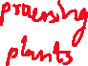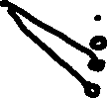

Buliding a flow network:

1 node per plantations n

1 node per ports n

1 node per barges per ports n*k

1 node per barges 1 k

1 node per barges 2 k

1 node per ports per barges m*k

1 node per ports m

1 node per processing plants m

10 plantations per node, so we send capacity of 10 from source S to each plantations n

Each plantation has each port n, so we have capacity 10 from plantation node to port node

Each barges has limited access to the port so we assign capacity ∞ from port to barges who have access to that port.

All the k barges meeting at the barge1 nodes have capacity ∞

Each barge can process only 25 units that’s why capacity 25 from barge1 node to barge2 node.

Each barge has limited access to the m ports so we have ∞ capacity from barge2 to k*m port nodes.

And all the meeting of k*m ports nodes to m ports nodes, we have capacity ∞

Each m ports can send 75 capacity to processing plants as processing plants can take up to 75

From processing plants nodes m we have capacity 75 to sink T

1. Argue that your transformation works. That is, the maximum flow of the flow network should tell you which ports each barge must stop at to pick up coffee (and how much to pick up) and which ports each barge must stop at to deliver coffee (and how much to deliver).
2. By Applying Max Flow Min Cut Algorithm, it gives us all the information regarding which ports each barge must stop at to pick up coffee (and how much to pick up) and which ports each barge must stop at to deliver coffee (and how much to deliver).

Max Flow Min Cut Algorithm saturates the necessary edges and ensures that there are no augmenting paths left in the network.

Consider a part of network flow from the above network flow graph to understand which ports each barge must stop to pick coffee and deliver coffee.

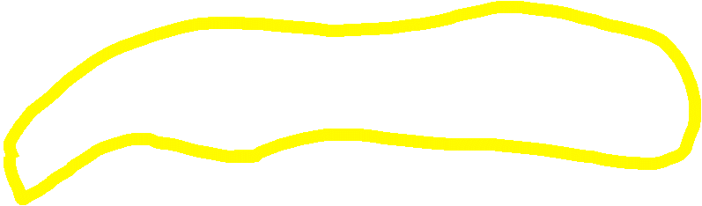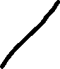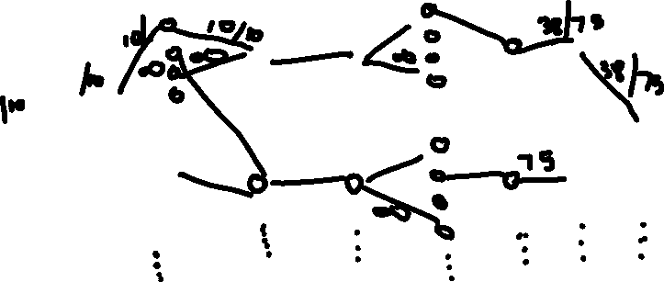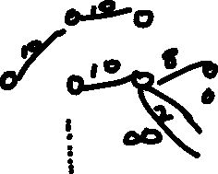

Consider the highlighted section of the above network graph, the k barges 1 nodes gives the details regarding which barge must stop to pick up coffee and from that flow we can trace from which port how many units are coming.

Regarding which ports barge must deliver, we can see the flow from k barges 2 to k*m port nodes and we can see how many units its delivering.

We keep capacity constraints at the plantations 10 per node and delivering for processing plants nodes have capacity 75, we limit the capacities such that the conservation flow is maintained.

1. Explain why the solution your algorithm produced is the best possible solution.
2. The solution of my algorithm is the best possible solution because of the conservation flow maintained according to the given constraints. The maximum flow minimum cut theorem, gives the best possible maximum flow which flows from the above graph by saturating the unnecessary edges. Maximum flow is sent from the plantations to the processing plants. My Algorithm will ensure that we will not send flow more than the capacity according to the constraints and this maintains conservation flow and we can not improve the algorithm further while satisfying the constraints according to the problem.

**2 Core is NP-Complete**

Let G = (V, E) be an undirected graph. We say that C ⊆ V is a core of G if for every vertex u ∈ V − C there exists v ∈ C such that (u, v) ∈ E. That is, every vertex in G is either already in the core, C, or is adjacent to some vertex in C. In this problem, you will show that it is NP-complete to determine whether a graph has a small core. Formally, we define Core by:

Core

INPUT: an undirected graph G = (V, E) and natural number k.

QUESTION: Does G have a core C, where |C| ≤ k ? I.e, does there exist C ⊆ V such that |C| ≤ k and for every u ∈ V −C there exists v ∈ C such that (u, v) ∈ E?

Recall that Vertex Cover was shown to be NP-complete in lecture:

VC

INPUT: an undirected graph G = (V, E) and natural number k.

QUESTION: Does G have a vertex Cover V| , where |V| | ≤ k ? I.e, does there exist V| ⊆ V such that |V| | ≤ k and for every edge (u, v) ∈ E, we have u ∈ V| or v ∈ V| ?

Show that Core is NP-complete by constructing a $≤_{m}^{P}$-reduction f from VC to Core.

1. Give an example of an undirected graph G and a number k such that (G, k) ∈ Core but (G, k) $∉$ VC. You can thus conclude that the identity function does not reduce VC to Core.

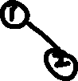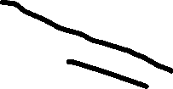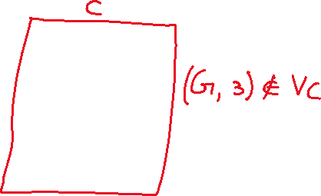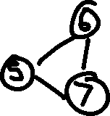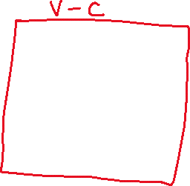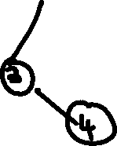

The above graph contains k=3 for core and k=4 for vertex cover.

Therefore, we cannot use identity function to reduce VC to Core.

1. Describe a polynomial-time function f that given input (G1, k1) outputs (G2, k2) where G1 and G2 are undirected graphs and k1 and k2 are natural numbers.

N.B.: the reduction function f has (G1, k1) as its ONLY input. It has no other information. In particular, it does not know whether G1 has a vertex cover with ≤ k1 vertices.

1. We need to reduce our polynomial time function f from VC to Core.

First we show Vertex cover runs in polynomial time and it is in NP.

If we reduce 3 satisfiability to any function then it belongs to NP.

3SAT $≤_{m}^{P}$ Vertex Cover

And then we show Vertex Cover $≤_{m}^{P}$ Core

VertexCover(VC)={(G,K) | V| V, |V||≤ k and for all (u,v) ∈ E either u ∈ V| or v ∈ V| .

Consider boolean function,=(u1 v v ) ^ ( v u2 v ) ^ (u2 v v )

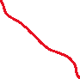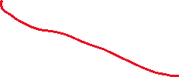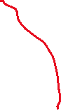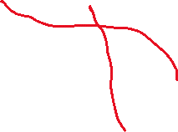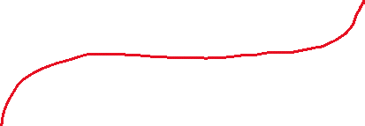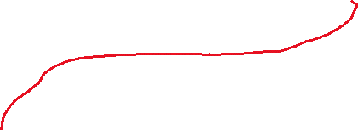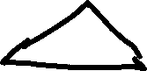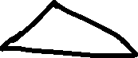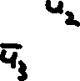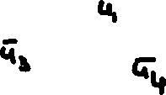

has n variables and m clauses

G has 2n+3m nodes

K=n+3m

Claim: $ϕ$ $∈$*3 SAT <=> G has a VC with k vertices*

*Proof:*

*Suppose $ϕ$ is satisfiable*

*Consider a satisfying assignment if ui is true, pick ui in variable gadget otherwise pick ${\overline{u}}_{i}$*

*Each clause must have a true literal, pick other 2 nodes in clause gadget.*

*u1=false, u2=true, u3=false, u4,=true*

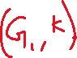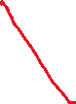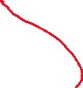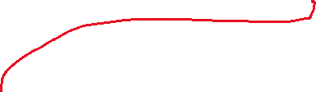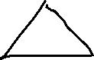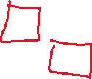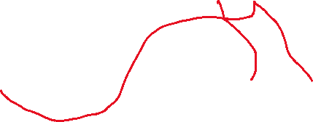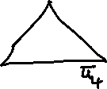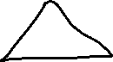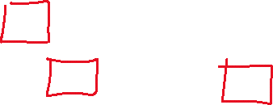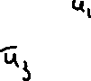

*Suppose G has a vertex cover with <= n+2m nodes*

*Each variable gadget has an edge that must be covered*

*Each clause gadget needs 2 vertex to cover 3 edges*

*Third node must be covered by variable gadget.*

*Therefore Each clause has a true literal.*

*Vertex Cover has been reduced from 3SAT in polynomial time function.*

*Now we reduce,*

Vertex Cover $≤_{m}^{P}$ Core

Consider the vertex cover gadgets described above:

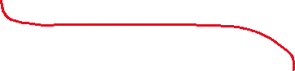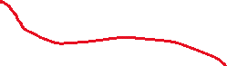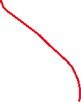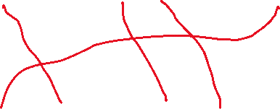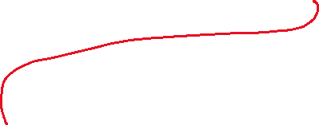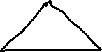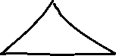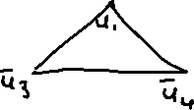

Consider the satisfying assignment for Core

*u1=true, u2=true, u3=false, u4,=false*

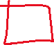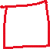

The above polynomial time reduction function takes (G1 ,k) as input and outputs (G2 ,k).

Each variable has one variable true

Each clause gadget has the true literal defined in the variable gadget, The VC ensures V-C edges attached to the C (Core).

1. Briefly argue that f runs in time polynomial in the size of G.

1. Our G has 2n+3m nodes and Vertex Cover has n+2m nodes and we proved with the satisfiability that VC runs in polynomial time .

Our Core Graph has n+m nodes which is less than the Vertex Cover nodes, as this is NP Problem we will be verifying the solution so we will be considering what the answer will be, so n+m runs in a polynomial time.

1. Prove that if (G1, k1) ∈ VC then (G2, k2) ∈ Core where (G2, k2) = f((G1, k1)) for the function f you described in part 1.
2. graph G = (V, E) and natural number k, G have a core C, where |C| ≤ k C ⊆ V such that |C| ≤ k and for every u ∈ V −C there exists v ∈ C such that (u, v) ∈ E

Claim: Vertex Cover $≤_{m}^{P}$ Core

Proof:

$ϕ$ has n variables and m clauses

G has 2n+3m nodes

K=n+m

Consider boolean function,=(u1 v v ) ^ ( v u2 v ) ^ (u2 v v )

Consider the satisfying assignment for Core (G2 ,k)

*u1=true, u2=true, u3=false, u4,=false*

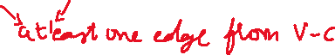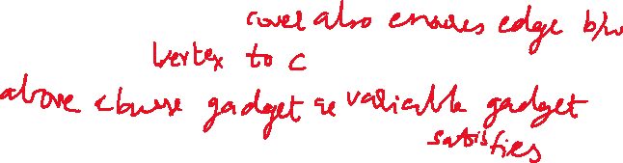

1. Prove that if (G2, k2) ∈ Core then (G1, k1) ∈ VC where (G2, k2) = f((G1, k1)) for the function f you described in part 1.



*Suppose G has a vertex cover with <= n+m nodes*

*Each variable gadget has an edge that must be covered*

*Each clause gadget needs 1 vertex to cover 2 edges*

*Therefore Each clause has a true literal.*

*To prove VC from Core we just need to cover one vertex in the clause gadget such that the Vertex Cover satisfies. So just ensuring each clause gadget has 2 vertex to cover 3 edges and the third edge will be covered by variable gadget.*

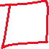

**3 Hamiltonian Cycle vs Hamiltonian Path**

The Hamiltonian Cycle (HC) and the Hamiltonian Path (HP) problems are similar, but different: Hamiltonian Cycle (HC)

Input: an undirected graph G = (V, E)

Decide: Is there a cycle in G that visits every vertex in V exactly once?

Hamiltonian Path (HP)

Input: an undirected graph G = (V, E) and two vertices s ∈ V and t ∈ V , where s ≠ t.

Decide: Is there a path from s to t in G that visits every vertex in V exactly once?

Construct a $≤_{m}^{P}$-reduction f from HC to HP. Then, prove your function f is indeed a polynomialtime many-one reduction. Use the following steps:

1. Give a high-level description of a polynomial-time function f that given an undirected graph G, outputs a graph G| and two vertices s and t.

N.B.: the reduction function f has G as its ONLY input. It has no other information. In particular, it does not know whether G has a Hamiltonian Cycle. Furthermore, f must output G| , s and t in the case where G has a Hamiltonian Cycle and when G does not have a Hamiltonian Cycle. Specifically, do not start your description with “Let (u, v) be an edge in a Hamiltonian Cycle of G.”

A.

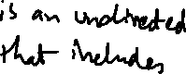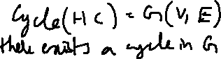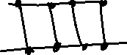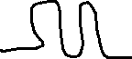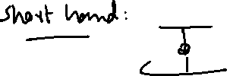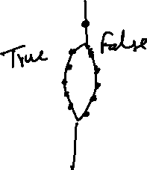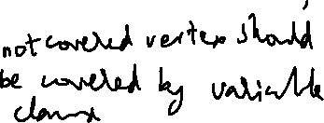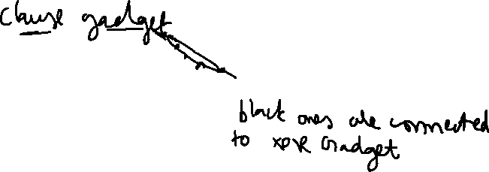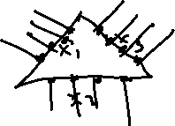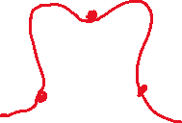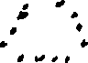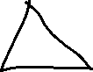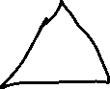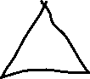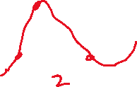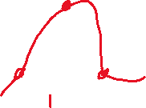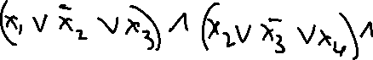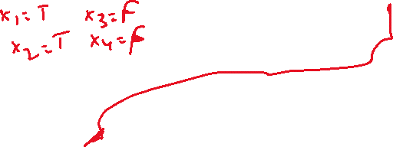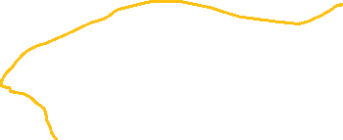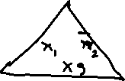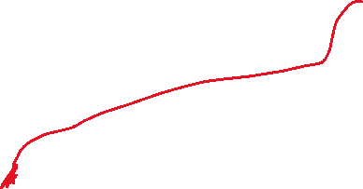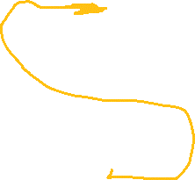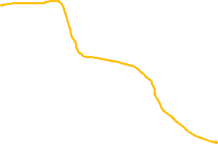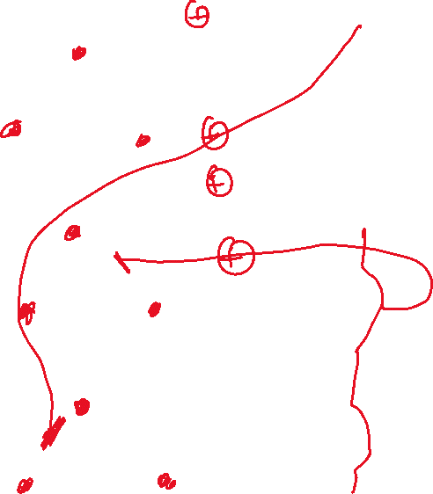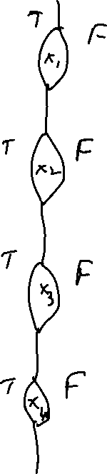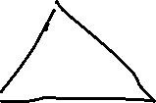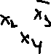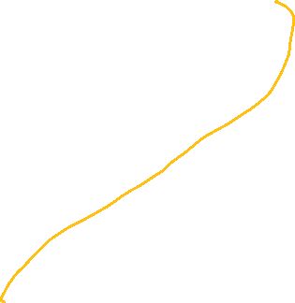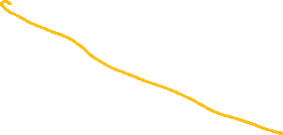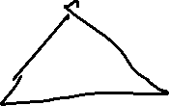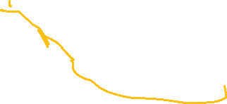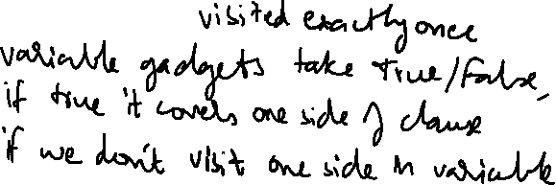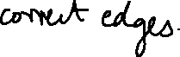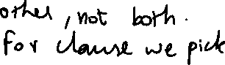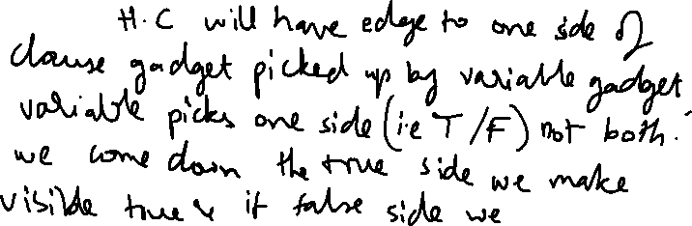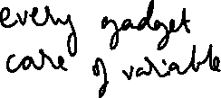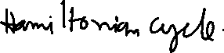

an undirected graph G = (V, E) and two vertices s ∈ V and t ∈ V , where s ≠ t.

a path from s to t in G that visits every vertex in V exactly once

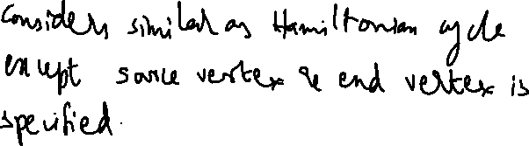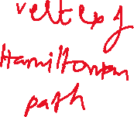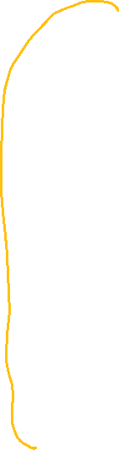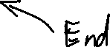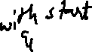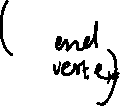

1. Briefly argue that f runs in time polynomial in the size of G.
2. We visit each node exactly once and there for we consider one edge per node we discard remaining edges.

Therefore the above function takes polynomial time with the help of XOR Gadgets.

1. Prove that for all undirected graphs G and (G| , s, t) = f(G) if G has a Hamiltonian Cycle, then there is a Hamiltonian Path from s to t in G| .
2. Above we have considered reducing the Hamiltonian path from Hamiltonian cycle.

Hamiltonian path is same as Hamiltonian cycle except start vertex and end vertex are specified in Hamiltonian cycle. HC consists of all vertexes so there also exists start vertex and end vertex of Hamiltonian path.

The XOR Gadgets helps us in visiting each vertex exactly once, The XORs other path traverse of vertex is handled by clause gadget.

By the satisfying assignment considered above it helps in identifying the Hamiltonian cycle in polynomial time.

From the Hamiltonian cycle we have reduced to Hamiltonian path.

Therefore, G and (G| , s, t) = f(G)

1. Prove that for all undirected graphs G and (G| , s, t) = f(G) if there is a Hamiltonian Path from s to t in G| then G has a Hamiltonian Cycle.

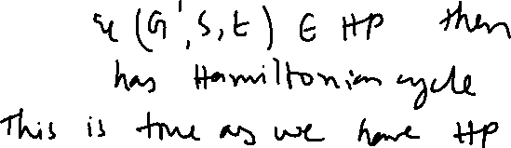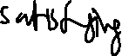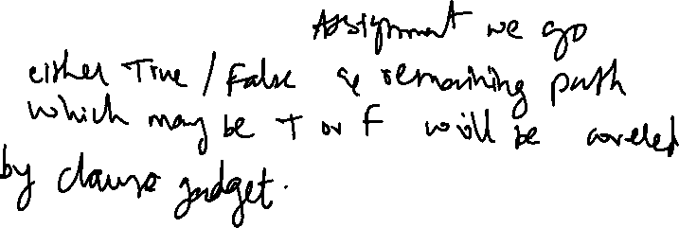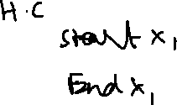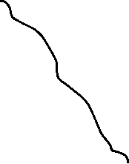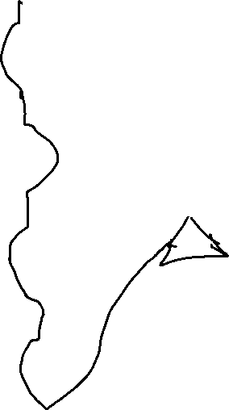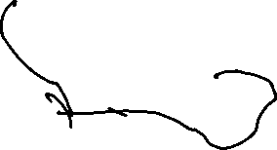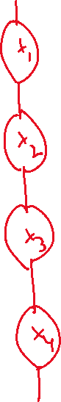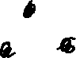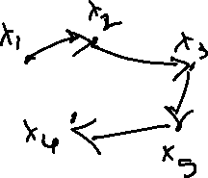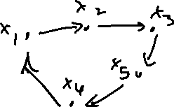

Above we have considered reducing the Hamiltonian path from Hamiltonian cycle.

Hamiltonian cycle is same as Hamiltonian path except start vertex and end vertex are not specified in Hamiltonian cycle. HP consists of all vertexes which have start vertex and end vertex. Hamiltonian cycle ends at the start vertex.

The XOR Gadgets helps us in visiting each vertex exactly once, The XORs other path traverse of vertex is handled by clause gadget.

By the satisfying assignment considered above it helps in identifying the Hamiltonian Path in polynomial time which we have proved above by reducing Hamiltonian cycle.

**References:**

<https://archive.org/details/introduction-to-algorithms-by-thomas-h.-cormen-charles-e.-leiserson-ronald.pdf/page/427/mode/2up>

<https://archive.org/details/AlgorithmDesign1stEditionByJonKleinbergAndEvaTardos2005PDF/page/n201/mode/2up>

[12.1-Network-Flow-post.pdf - Google Drive](https://drive.google.com/file/d/1ficlMZfdGn0b0rmSGNA-B5rajJXm9nmt/view)

[12.2-Max-Flow-Min-Cut-post.pdf - Google Drive](https://drive.google.com/file/d/1wD7eeejVifFcLdMZb8d0O1KgSkwbujX1/view)

[13-Network-Flow-Applications-post.pdf - Google Drive](https://drive.google.com/file/d/1ByCXRh9b2LICYCc77viRIpjUBim2nLqW/view)

[15.3 Edmonds-Karp with Proofs (optional).pdf - Google Drive](https://drive.google.com/file/d/1ltWPUoRkU0BsWUKEeesXAfy52sjbBHVT/view)

[16-NP-Completeness-post.pdf - Google Drive](https://drive.google.com/file/d/1bivjSeiI1jMDGqHUSvmiSJDQP5vfUj1e/view)

[17.1-SAT-vs-Coloring-post.pdf - Google Drive](https://drive.google.com/file/d/14tXdHCCKhN7gRvXdldfF6GrI1Y1noYeT/view)

[18.3-Hamiltonian-Cycle-post.pdf - Google Drive](https://drive.google.com/file/d/1P8TPqAuQsrW43JzkQrnGLe9GmYMFj5OH/view)